Incident handler's journal
Date: 01/18/26 | Entry: 3
Description | Capturing a packet
Tool(s) used | I used the tcpdump command in Linux to capture and analyze network traffic. This command is helpful for security specialists to investigate activities in the network.
The 5 W's | - Who: N/A  - What: N/A  - When: N/A  - Where: N/A  - Why: N/A
Additional notes | Compared to Wireshark, using tcpdump is much more challenging due to the command-line interface.

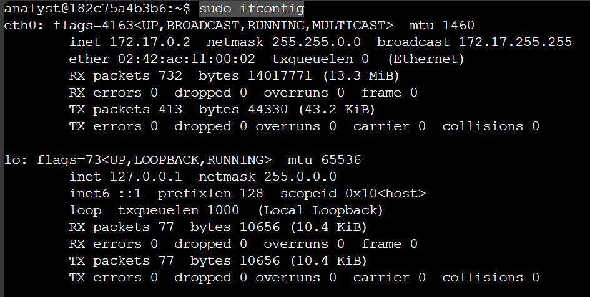
I captured and filtered network traffic in a Linux environment using tcpdump. The ifconfig command was used to identify available network interfaces. The Ethernet network interface is identified by the eth prefix.
I used the command tcpdump -I eth0 -nn -c9 port 80 – w capture.pcap & to capture network traffic with tcpdump. This command also saves the network traffic to a packet capture file. The -I eth0 portion captures data from the eth0 interface. The -nn portion is to not attempt to resolve IP addresses or ports to names. This would help prevent malicious actors from being alerted. The -c9 portion means that the command will capture 9 packets of data and then exit. The port 80 filters only the default HTTP port of port 80. The -w capture.pcap saves the captured data to the named file. The & is an instruction to run the command in the background.

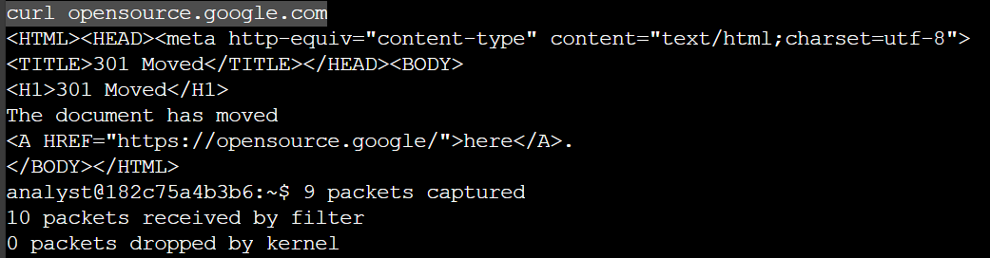
The curl command was used on the domain opensource.google.com to generate HTTP traffic that can be captured.
The ls -l command was used on the file capture.pcap to verify if packet data was captured.
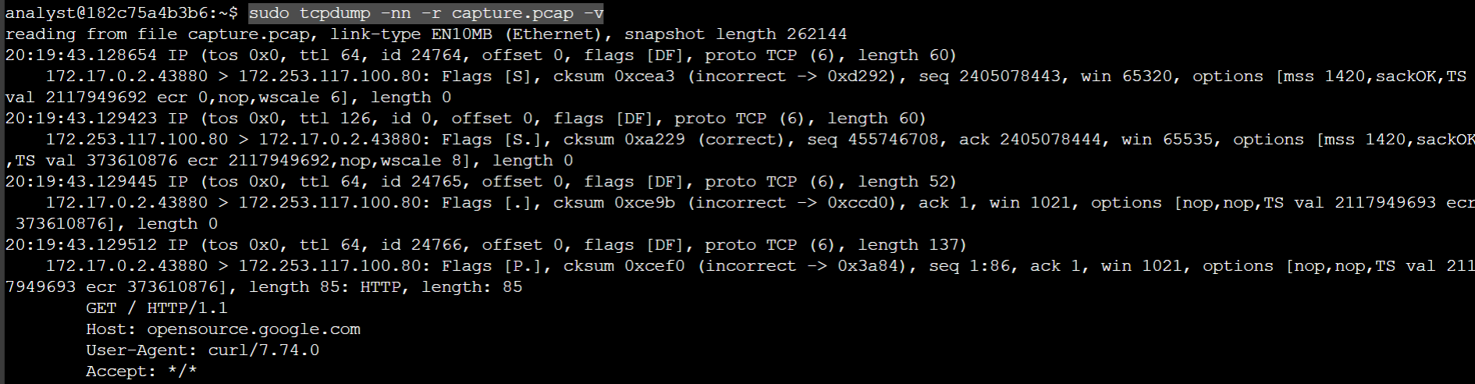
To filter the captured packet data I used tcpdump -nn -r capture.pcap -v. The -nn condition is there again so that tcpdump does not perform name lookups of IP addresses or ports to not alert threat actors. The -r portion reads capture data from the file. The -v condition displays detailed packet data. IP packet information and packet data can be seen.

